**Practical – 2**

**Aim: To demonstrate configuration of Mail Server (SMTP)**

**Scenario:**

Mr. Tim is planning to set up the network for his company’s branch office

which contains 2 departments - Department A and Department B. The

configuration should be done such that all the devices in those departments

should be able to reach each other. For security reasons, Mr. Tim doesn't

want to use any external company service for mail. So, he asked his

Network Engineer to set up the server in the company premises only to use

the mail services. Therefore, help the network Engineer to do the same.

Note the important point while designing and implementing the network.

The branch office is connected to the main office. Therefore you need to

show the network of the main office as well.

The mail domain of the main office is future.first.in and the mail domain of

the branch office is future.second.in. All the users in the main office and

branch office should be able to send and receive the mail. Design the

network so that at least 2 users are there in branch office and at least 2

users in the main office.

**Configuration:**

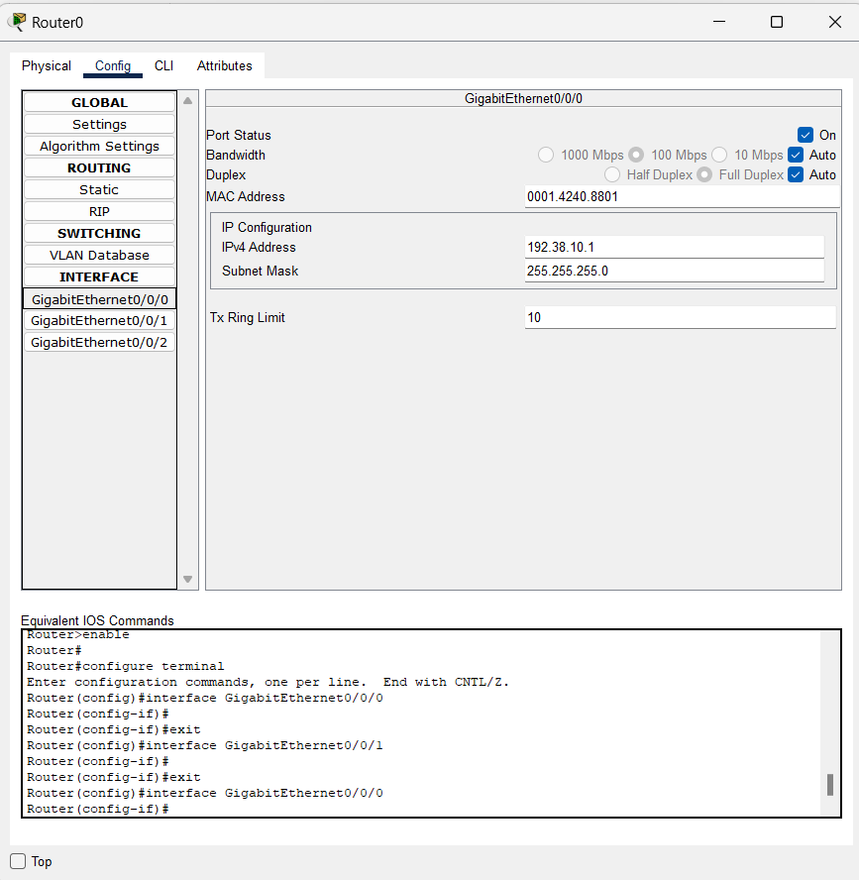**Router:**

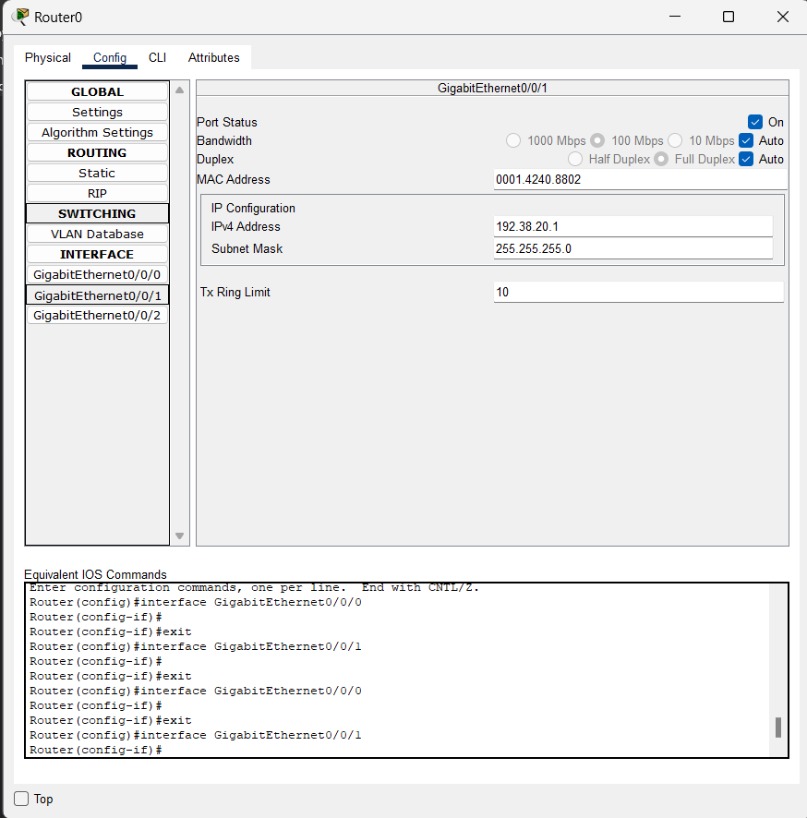

**DNS:**

Ip//

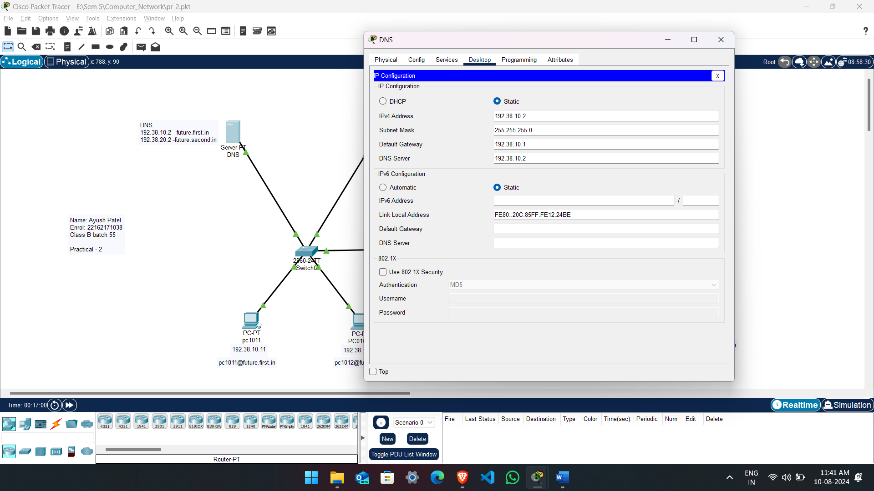

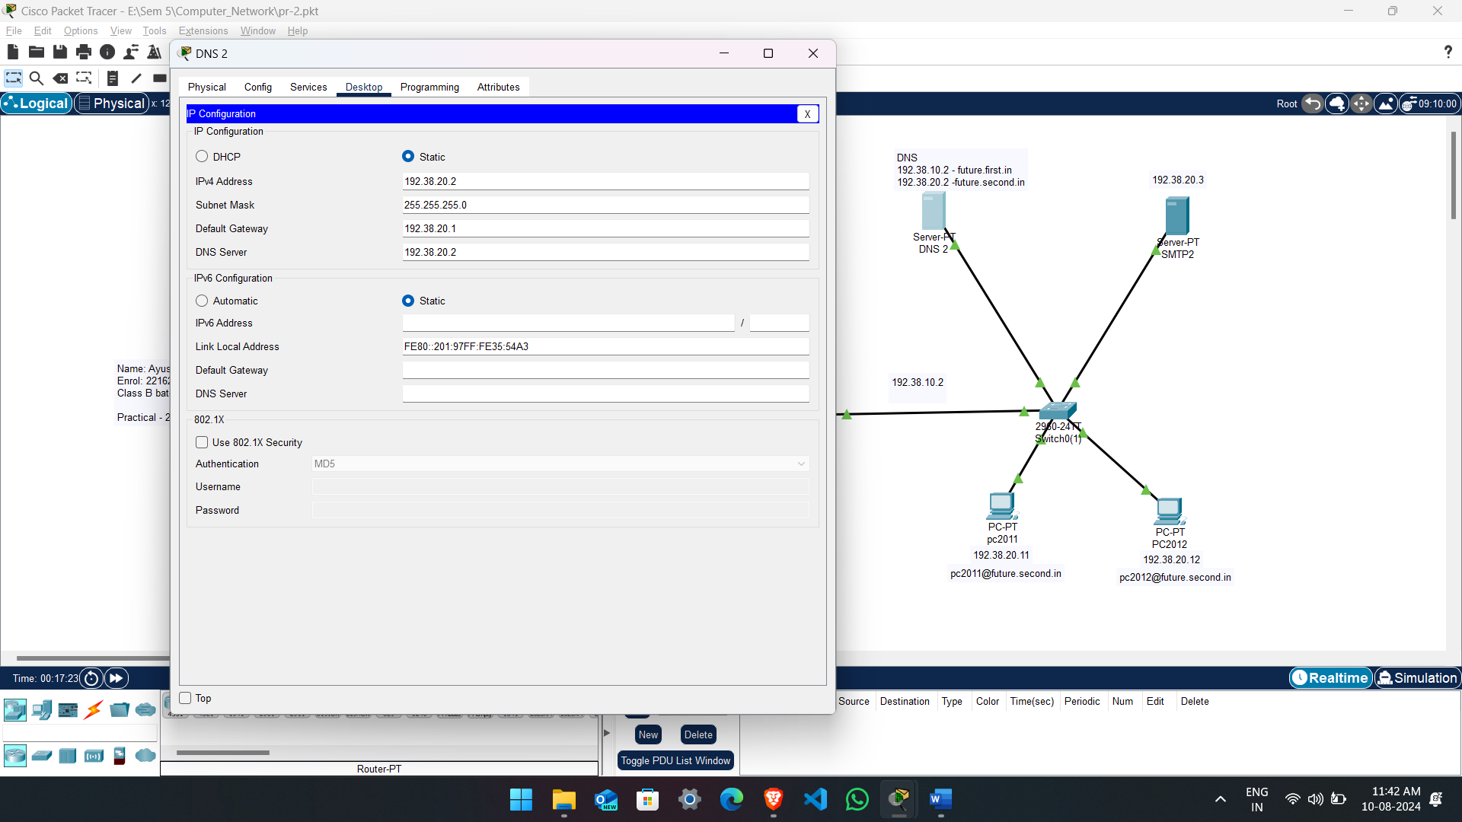

DNS/ Server :

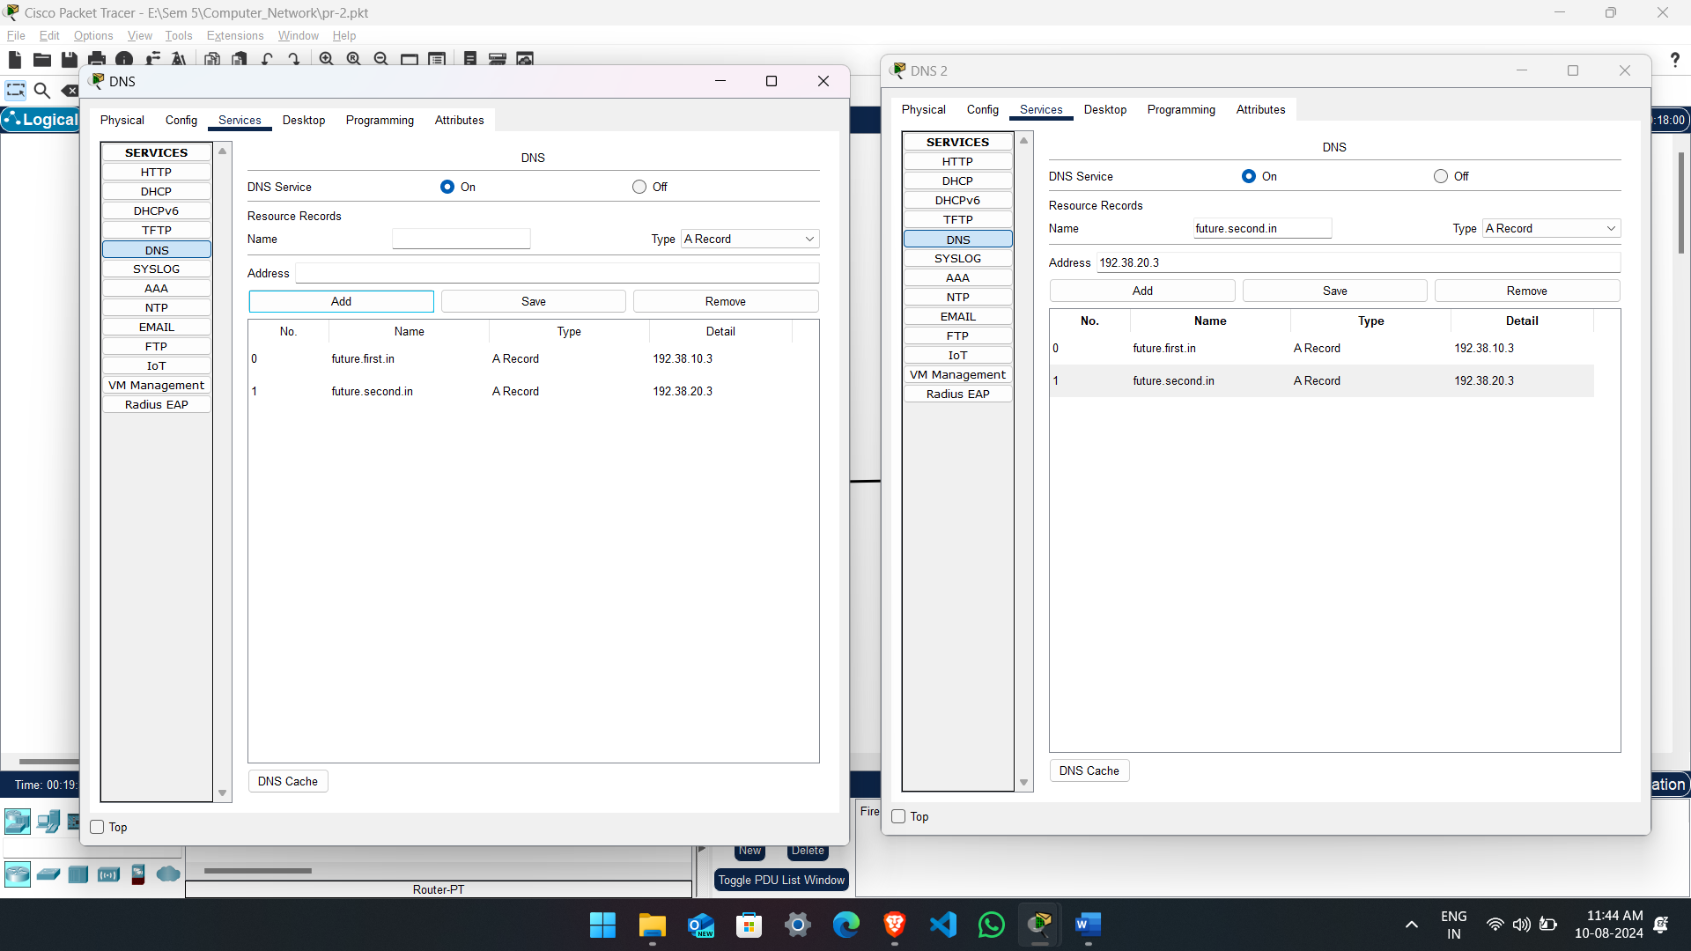

SMTP/ IP config:

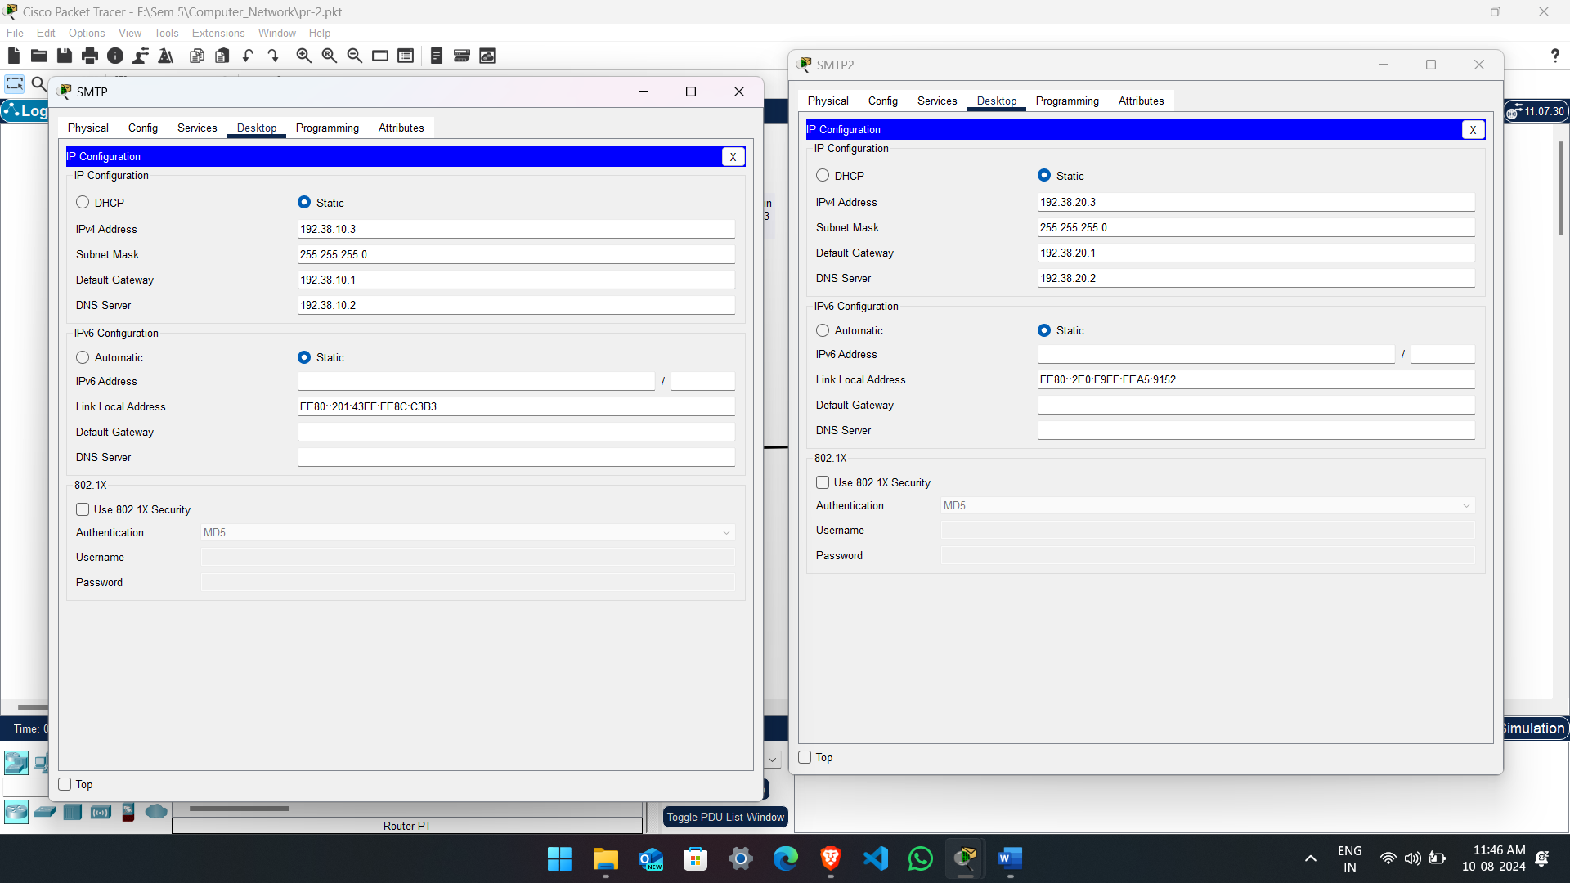

SMTP/ email

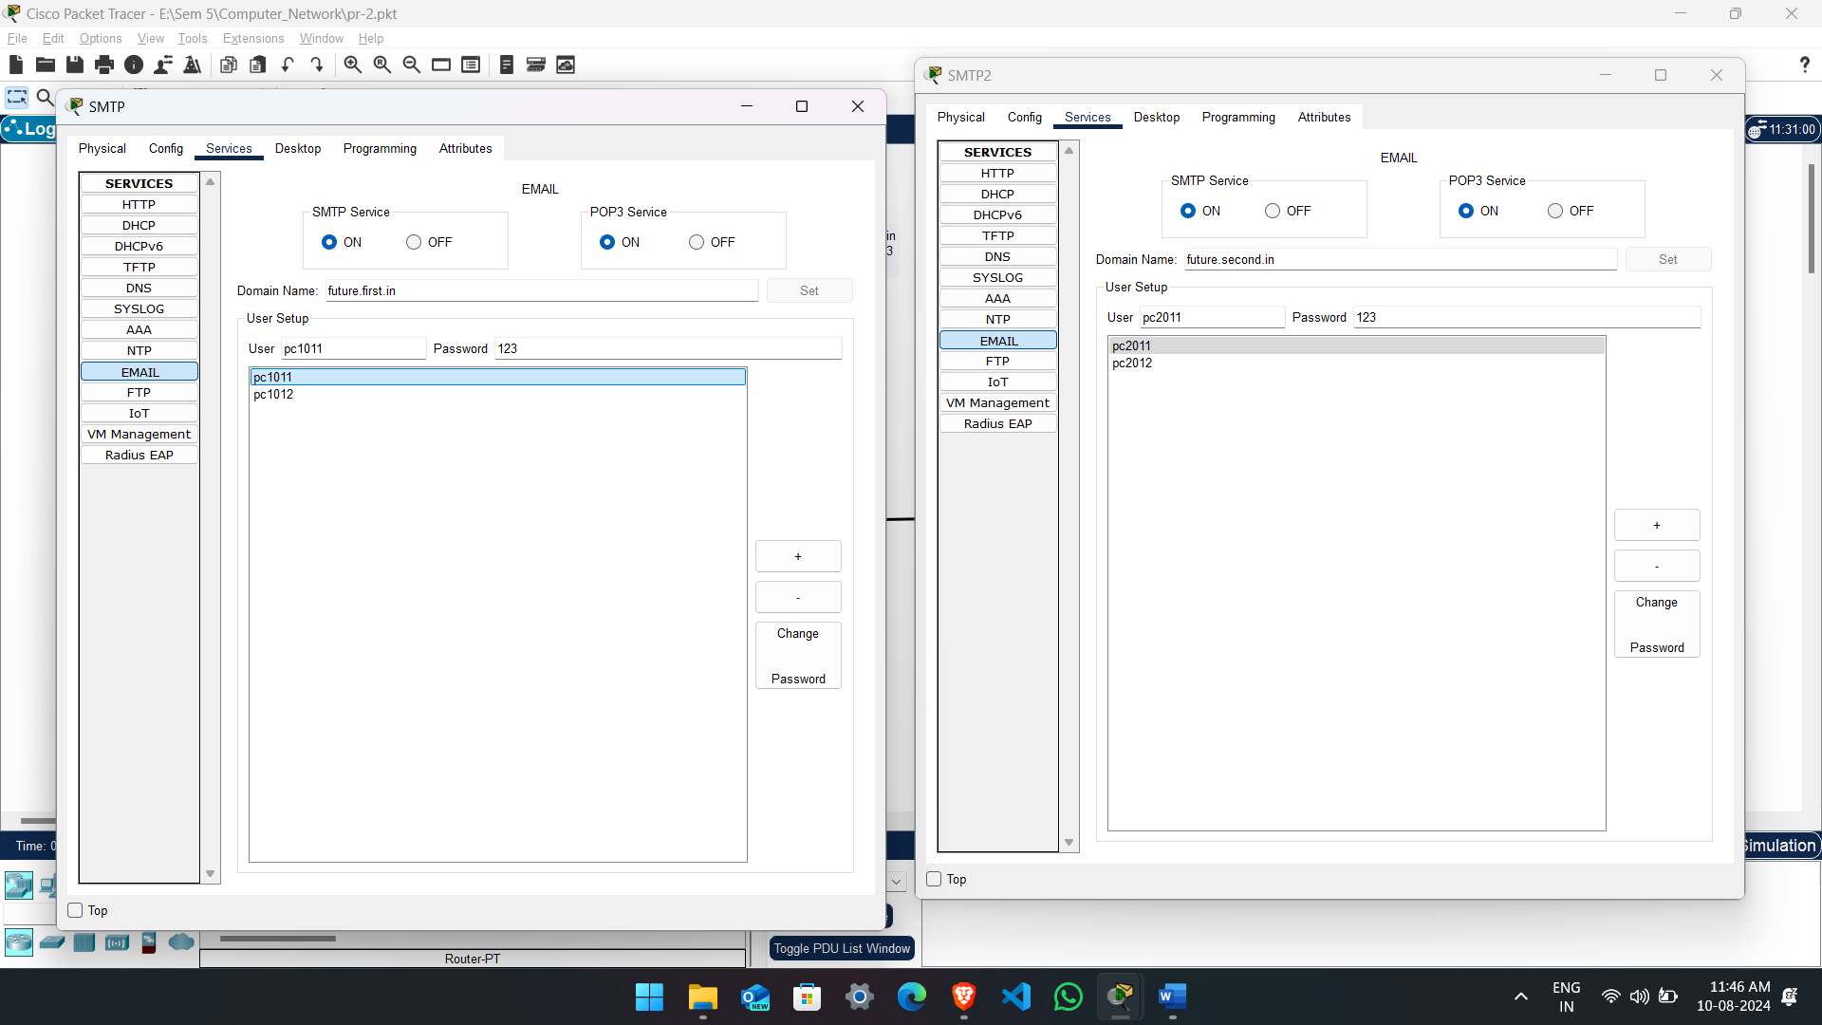

PC Config – each from one side

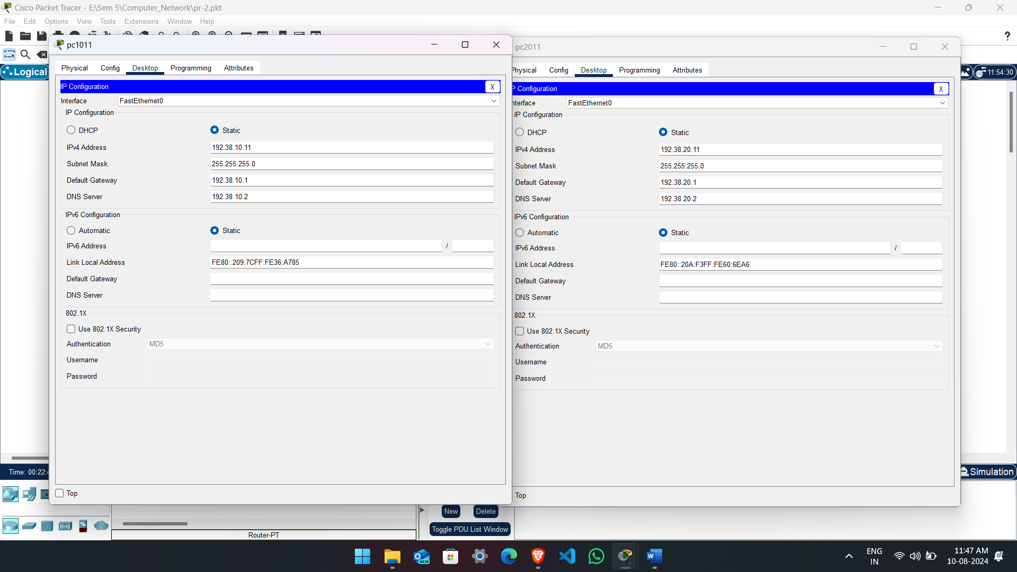

PC Configuration for email :

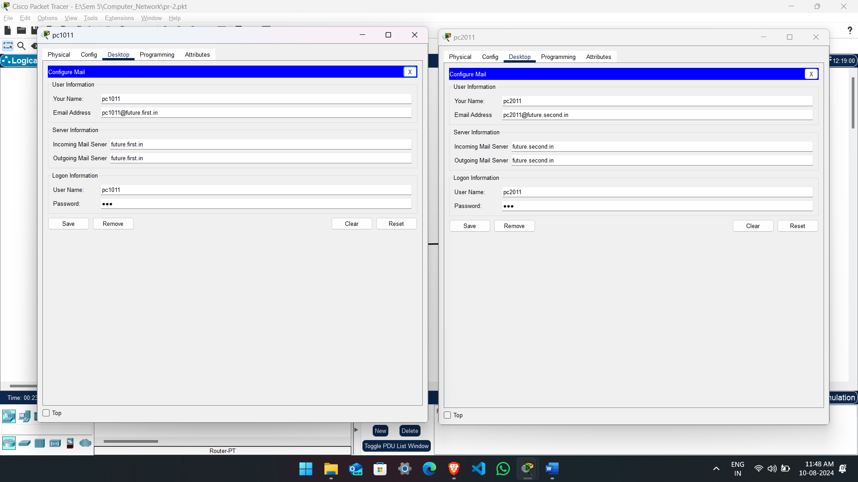

Over all Structure:

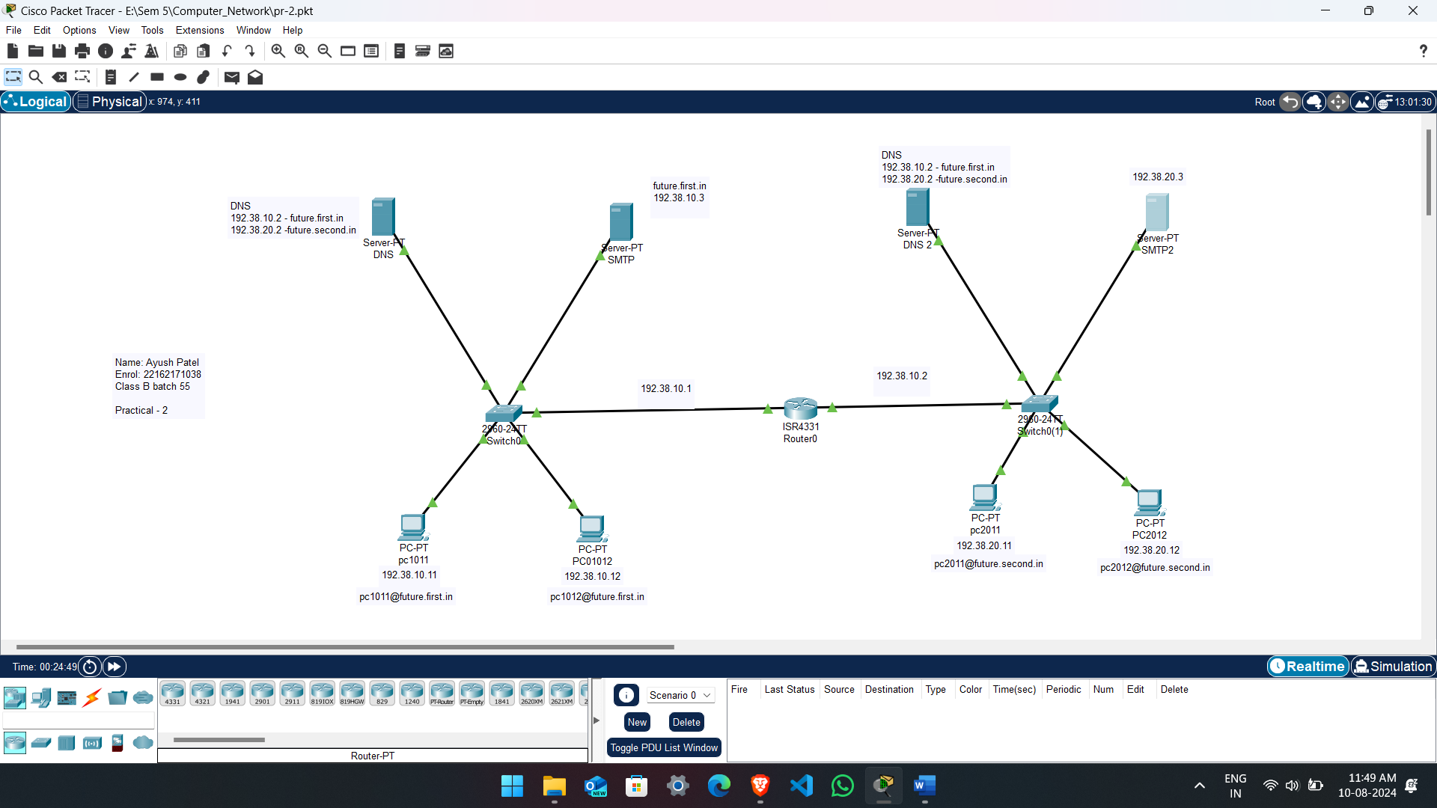

Output:

Sending email locally: (PC1011 To PC1012)

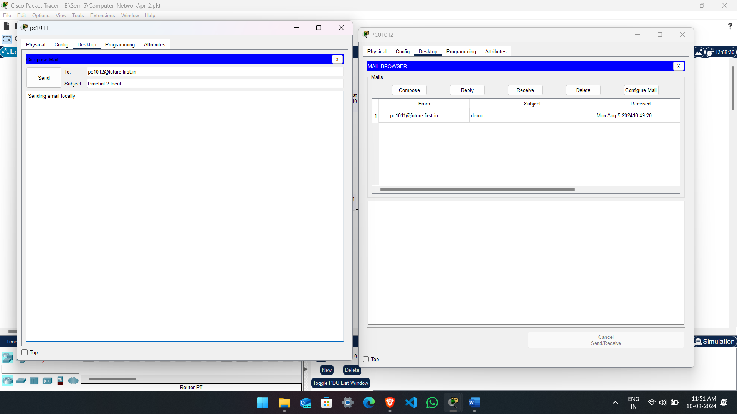

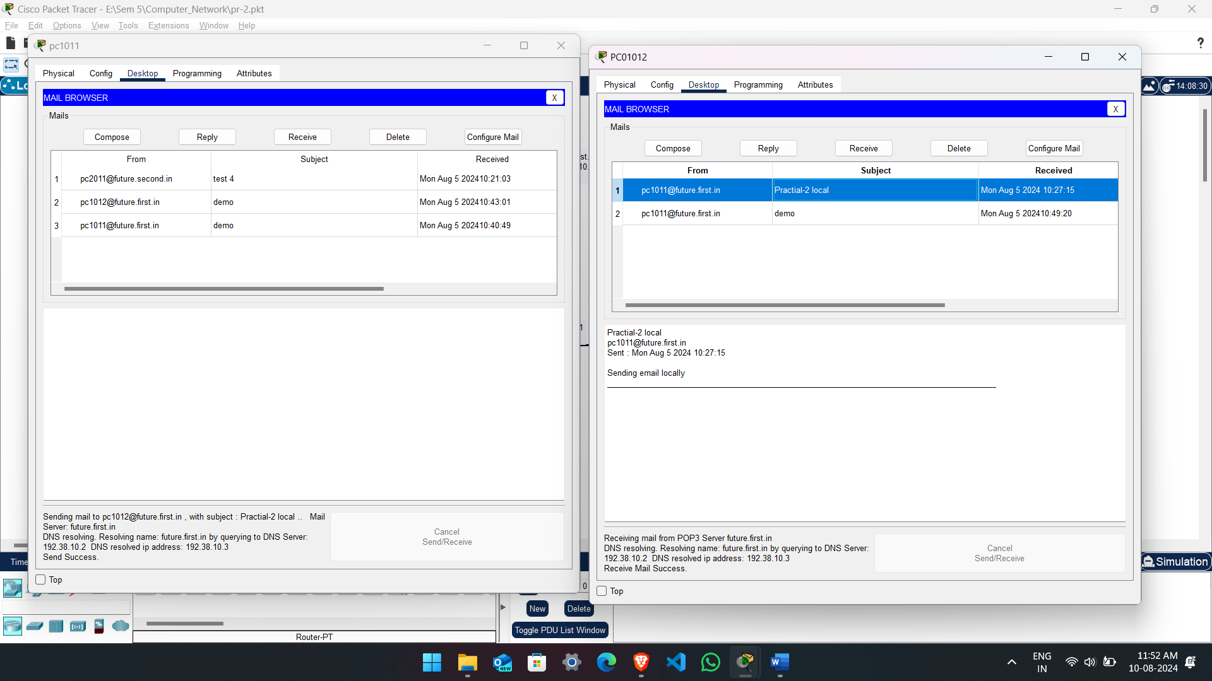

Sending email from pc2011 to 1011

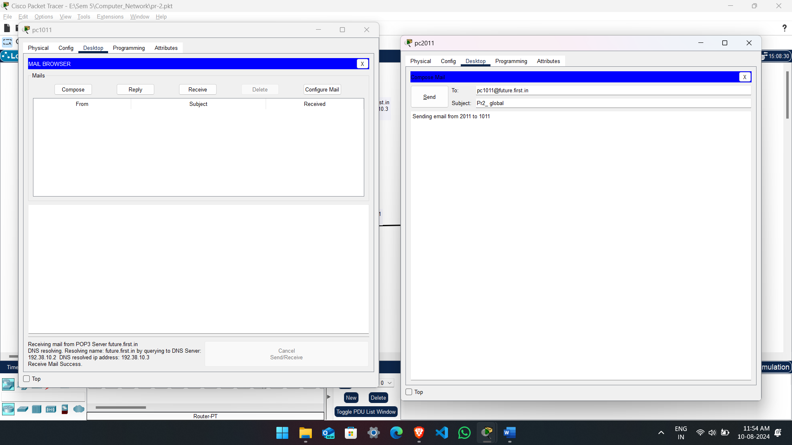

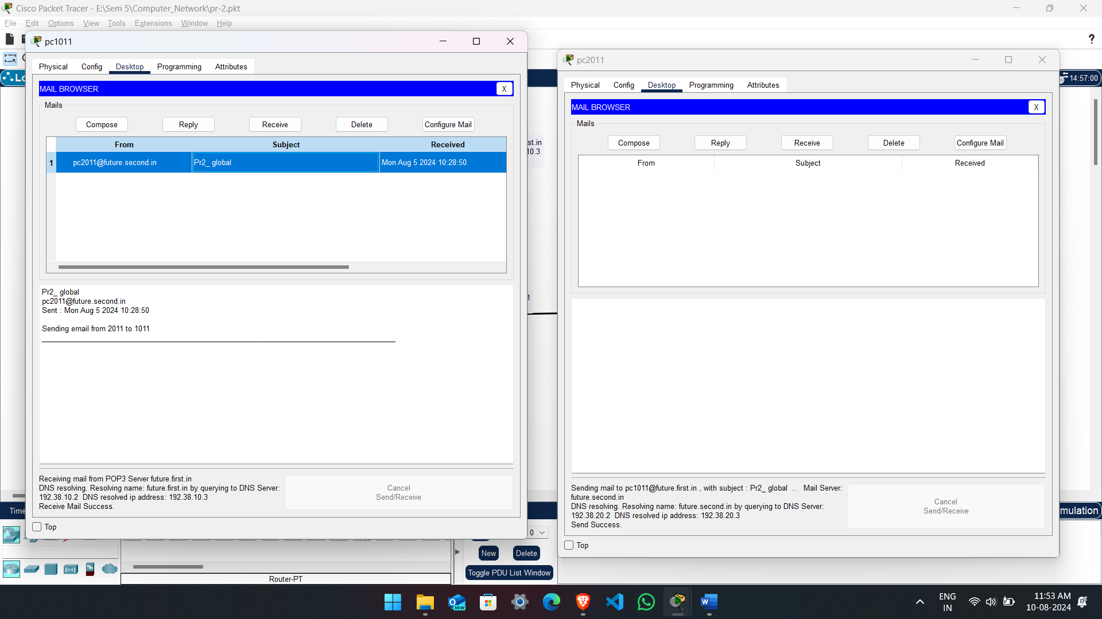

Conclusion:

We can say that If we have to send email from one pc to another we have to create a DNS server with all the other Ip which are smtp , pc and other local system’s DNS server Ip which will help it to communicate with each other send email through the network easily.